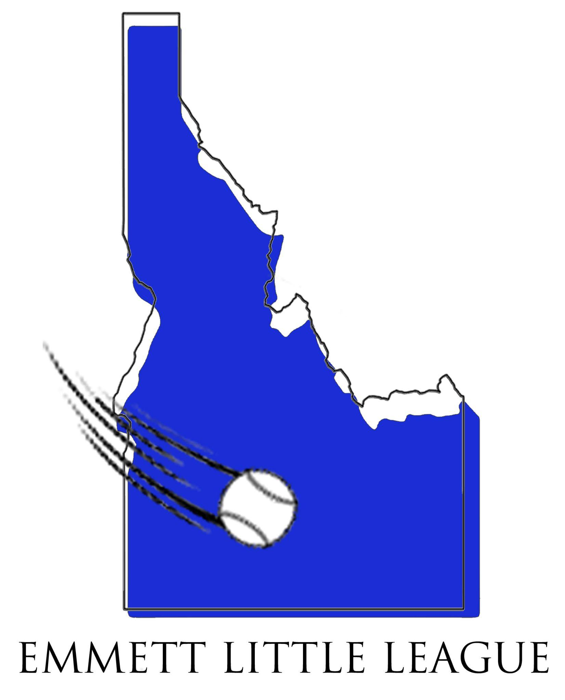
EMMETT LITTLE LEAGUE
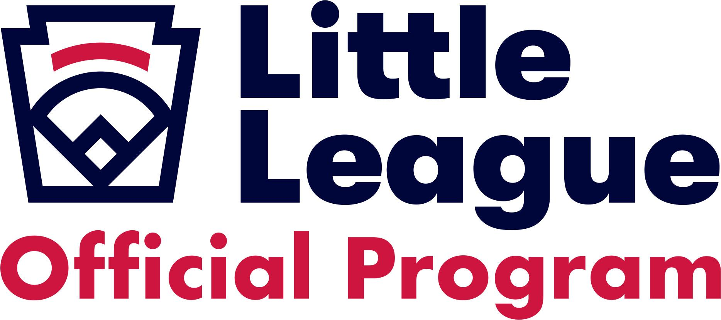

Dear Friend of Youth Baseball:
Emmett Little League is a non-profit organization dedicated to providing a positive baseball experience for all children while instilling the values of teamwork, sportsmanship and fair play. We depend on the support of our volunteers, sponsorships, and donations from our community to help us pay for uniforms, equipment, training & field maintenance, and player scholarships. Emmett Little League participants include over 120 players and their families. As a donor, your business will gain valuable visibility throughout the community. You can showcase your business to hundreds of people who attend Emmett Little League games from Emmett and throughout the Treasure Valley.
We recognize and appreciate how amazing our community is and the level of financial commitment which is present from Emmett businesses. Please consider how you can help support the players of Emmett Little League. We offer different levels of sponsorship, as seen below, but we appreciate and welcome any size of donation. If you are interested in contributing, please complete the attached Sponsorship Form along with your payment and business card and return to:
Emmett Little League
Attn: Sponsorships
PO Box 276
Emmett, ID 83617

Once we receive your tax-deductible donation, you will receive a letter of confirmation and our Non-Profit Tax ID#.
If you have any questions, please feel free to contact one of the following Sponsorship Coordinators:
Matt Kurata, 541-212-3071, mkurata50@gmail.com
Jon Wissel, 208-207-3377, jon@emmettlittleleague.com
Thank you for your consideration and for your support!
Sincerely,
Emmett Little League Board of Directors
EMMETT LITTLE LEAGUE 2026 SPONSORSHIP PROGRAM

Field Sponsor - $1000 – SOLD OUT
- Sponsor will receive a banner that will be displayed on sponsored field’s backstop
- Field will be referred to as Sponsor’s field during the entire 2026 Emmett Little League Season
- Sponsor’s name will appear on ALL schedules (paper schedules, website, Facebook, etc) whenever a game or event takes place at a designated field. Our schedules are shared with the Emmett Community and throughout the Treasure Valley (for Inter-League Play).
- Sponsor will be listed on our Emmett Little League website

Jersey Sponsor - $600 – 10 Teams Available
- Sponsor’s name will appear on sponsored team’s jerseys
- Sponsor’s name will appear on a banner, which will be displayed on an outfield fence (on 1 of our 4 Emmett Little League Fields)
- Sponsor will be listed on the Emmett Little League website
- We will do our best to be sure your sponsorship appears on your child’s team

Warm-Up Sponsor - $600 – 12 Team Available
- Sponsor’s name will appear on sponsored team’s warm-up jackets
- Sponsor’s name will appear on a banner, which will be displayed on an outfield fence (on 1 of our 4 Emmett Little League Fields)
- Sponsor will be listed on the Emmett Little League website
- We will do our best to be sure your sponsorship appears on your child’s team

Banner Sponsor - $300
- Sponsor will receive a banner that will be displayed on an outfield fence (on 1 of our 4 Emmett Little League Fields)

EMMETT LITTLE LEAGUE 2026 SPONSORSHIP REQUEST

Sponsorship Information
Company Name: ____________________________________________________________________
Contact Person: _____________________________________________________________________
Phone: ________________________ Email: _______________________________________
Address:_____________________________________________________________________
City:__________________________ State:___________ Zip Code:________________
Company Website:____________________________________________________________________

Sponsorship Program selected:
[ ] [ ] Donation
[ ] Team Jersey Sponsor $600 [ ] Other
[ ] Warm Up Sponsor $600 [ ] Banner Sponsor $300

Pledge Donation
• Donation Amount $ _______________
• Other: ______________________________________

Return this form, along with your payment and business card to:
Emmett Little League
Attn: Sponsorships
P.O. Box 276 Emmett, ID 83617

We would appreciate all payments be made by March 1, 2026.

